Automatic Room Light
Description:
A project using a Light Dependent Resistor (LDR) to detect light intensity and control an LED or light bulb accordingly.
Block Diagram:
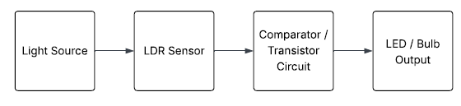
Pinout / Circuit Connection:
LDR → Analog Input A0 on Arduino
10kΩ Resistor → connected with LDR for voltage divider
LED → Digital Pin 9 (with 220Ω resistor)
Components Required:
Arduino UNO
LDR
10kΩ Resistor
LED
220Ω Resistor
Breadboard
Jumper wires
Working Principle:
The LDR changes its resistance based on the light falling on it. Arduino reads the voltage from the voltage divider and switches the LED ON/OFF depending on threshold.

Operation (Step-by-Step):
Power the Arduino.
LDR senses ambient light.
Arduino compares LDR value with threshold.
If dark → LED turns ON.
If bright → LED turns OFF.
Arduino Code:
int ldrPin = A0; // LDR connected to analog pin A0
int ledPin = 9; // LED connected to digital pin 9
int threshold = 500; // Light threshold (adjust if needed)

void setup() {
pinMode(ledPin, OUTPUT);
Serial.begin(9600);
}

void loop() {
int ldrValue = analogRead(ldrPin); // Read light intensity
Serial.println(ldrValue);

if (ldrValue < threshold) {
// DARK condition (lights OFF)
digitalWrite(ledPin, HIGH); // LED ON
} else {
// BRIGHT condition (lights ON)
digitalWrite(ledPin, LOW); // LED OFF
}

delay(200);
}
Conclusion: (Predefined/self-written)
The LDR-based Light Sensor project teaches how sensors can automate lighting systems based on environmental conditions.

For Your References:
[1] Arduino.cc, 'Analog Read Reference,' https://www.arduino.cc/en/Reference/AnalogRead

